Name____________________________________Class__________________Date__________

Sound Crossword Puzzle

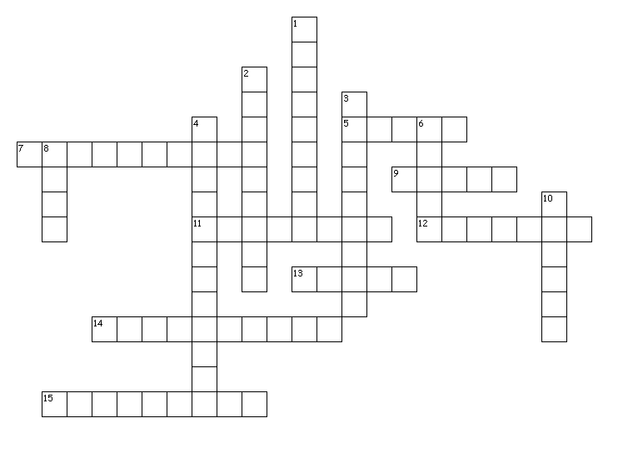

Across

5. A sound wave that is produced in an irregular pattern.

7. This type of wave requires a medium to travel through.

9. A sound wave that is produced in a repeating pattern.

11. This describes your perception of the energy of a sound.

12. The unit that measures how loud a sound is.

13. A description (perception) of how high or low the sound seems to a person.

14. Hearing damage occurs at this level.

15. The pitch of a sound that you hear depends on this.

Down

1. All sound waves begin with this.

2. This wave property causes loudness.

3. The amount of energy a sound wave carries per second through a unit area.

4. The process by which a location is detected by using sound waves.

6. A disturbance that travels through a medium as a longitudinal wave.

8. A reflected sound wave.

10. The material through which a wave travels.